D.C. Contract Appeals Board
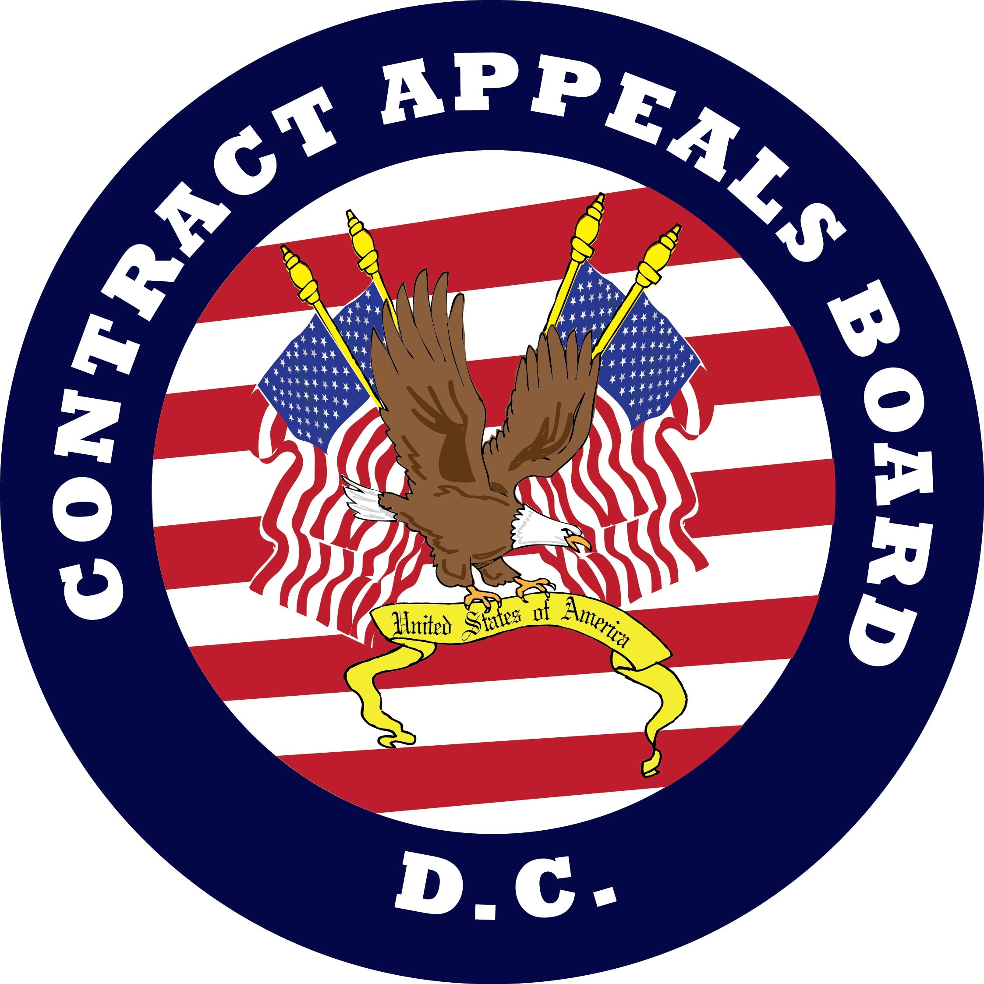
Organization Chart
(Effective December 9, 2019)

